|  |
| --- |
|  |
|  |

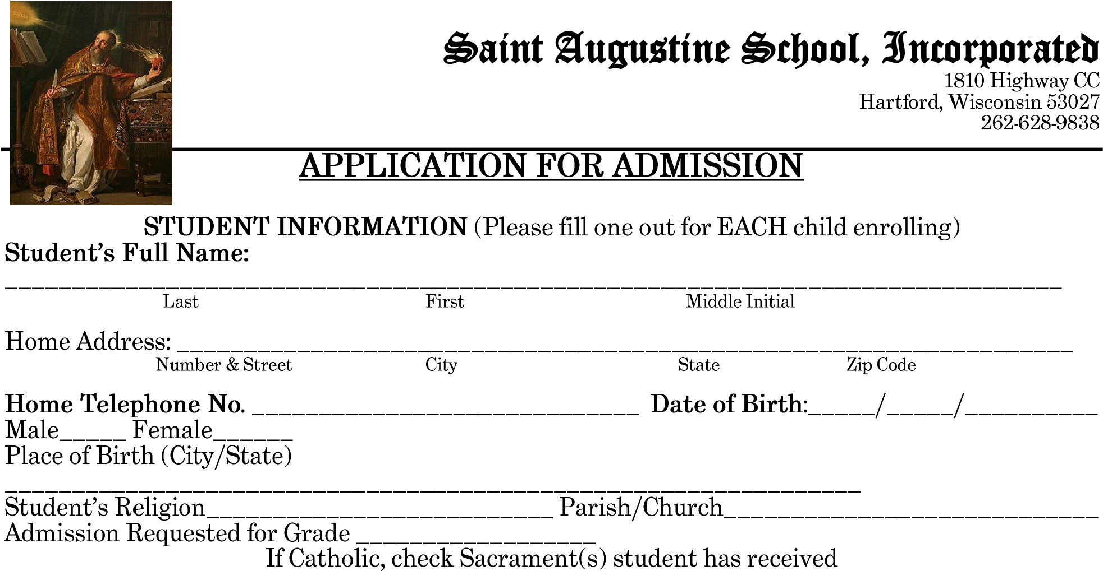

APPLICATION FOR ADMISSION

**SACRAMENTS**

|  |  |  |  |  |
| --- | --- | --- | --- | --- |
|  |  |  |  |  |
|  |  |  |  |  |
|  |  |  |  |  |
|  |  |  |  |  |
|  |  |  |  |  |

**SCHOOLS ATTENDED**

|  |  |  |  |
| --- | --- | --- | --- |
|  |  |  |  |
|  |  |  |  |
|  |  |  |  |
|  |  |  |  |
|  |  |  |  |

**OTHER CHILDREN IN THE FAMILY**

|  |  |  |  |
| --- | --- | --- | --- |
|  |  |  |  |
|  |  |  |  |
|  |  |  |  |
|  |  |  |  |
|  |  |  |  |
|  |  |  |  |

